Tofu Tacos
YIELD 2 SERVINGS  Ingredients  4 six-inch corn tortilla shells  1 cup extra firm tofu cubed  1 small tomato chopped  1 green onion diced  1/2 avocado pitted and diced  1 tsp turmeric powder  1/4 tsp garlic salt  pepper to taste  Nutritionals Per Serving  □ Calories 310 Cal  □ Protein 14 grams  □ Fiber 4 grams  □ Sugar 2 grams  □ Carbs 30 grams  □ Fat 13 grams | PREP 10 MIN | COOK 5 MIN | TOTAL 20 MIN  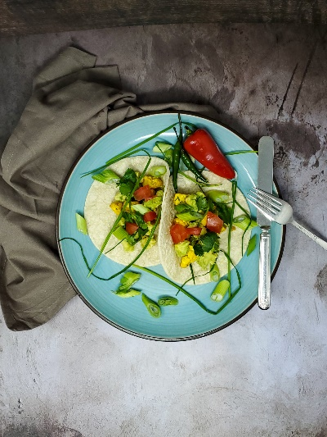  Directions  Step 1  Chop up your onion, tomato and avocado and set aside to top your tacos.  Step 2  Take your tofu and dice into bite size cubes and place in a small mixing bowl. Toss in your turmeric powder, garlic salt and pepper and mix well. Cook up the tofu over medium heat on a cook top, tossing to heat up all sides for about 5-10 minutes. Set aside while you are heating up your wraps.  Step 3  Heat up the tortilla wraps in the microwave for 30 seconds or heat over a gas stove top flipping on both sides for 5-10 seconds trying not to burn the shell. Set aside in a warming shell container or wrap them in foil.  Step 4  Build your tacos by placing a shell on your serving plate. Add your tofu and top your tacos with your preferred toppings of choice. You are ready to enjoy!  Tips  You can add any spice or seasoning to your tofu like the traditional taco seasoning or a marinade of your choice if you prefer. Add a little water to the tofu so the seasoning coats well if your mixture is lumpy. Tacos are best if you warm up your shells before serving.

