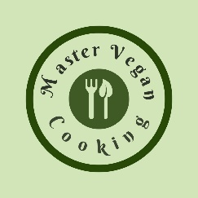

Avocado Flatbread
YIELD 2 SERVINGS  Ingredients  2 small single size flatbreads 2 oz  1/4 cup vegan pesto sauce  1 avocado sliced  1/2 cup tomato cherries cut in half  1/2 cup arugula  1/4 cup pine nuts  Nutritional’s Per Serving  □ Calories 470 Cal  □ Protein 9 grams  □ Fiber 6 grams  □ Sugar 2 grams  □ Carb 29 grams  □ Fat 19 grams | PREP 10 MIN | COOK 0 MIN | TOTAL 10 MIN  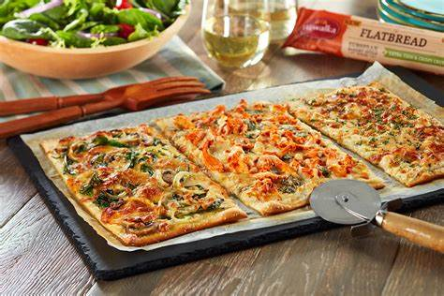  Preparations  If you want to serve your flatbread at room temperature for a summer dish place it on a serving plate or wood board to then assemble. However, if you want to warm it up in an oven place it on a pizza pan.  Once your flatbreads are in place, poor the pesto sauce on each flatbread and spread a thin layer on most of the bread.  Cut the cherry tomatoes in half and set aside. Take the fresh avocado and cut in half around the pit. Split open and take out the pit with a spoon and make slices lengthwise on each half of the avocado. Scoop out the flesh leaving the slices intact.  Gather all your toppings and place them on the flatbreads trying to keep them spread out to cover the entire flatbread. It is best to add the arugula last because it is the lightest ingredient.  You can plate the whole flatbread on your serving dish or slice it up with a pizza slicer to serve. If you intend to heat the flatbread up place in an oven for 4 minutes at 325 or under a broiler for 1 minute. Once your flatbread is ready serve and eat up!  Tips  To save time purchase your flatbread pre-made this will save a lot of time and is the best way to go if you are in a rush. If you want to save money and you have time you can make your own flatbread. Use up any topping you have in your kitchen if you do not have the specific ones on hand.

Notes

