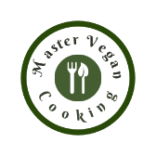 Breakfast Quesadilla
YIELD 2 SERVINGS  Ingredients  4 flour tortillas  1 small sweet potato peeled & diced  ½ cup shredded Daiya cheese  1 jalapeno diced & roasted  1 red bell pepper stemmed, diced and roasted  ½ cup cooked black beans, drained & rinsed  ¼ cup scallions chopped  1 tsp Mexican blend spice  Nutritional’s Per Serving  □ Calories 363 Cal  □ Protein 11 grams  □ Fiber 11 grams  □ Sugar 0 grams  □ Carbs 53 grams  □ Fat 10 grams | PREP 15 MIN | COOK 15 MIN | TOTAL 30 MIN  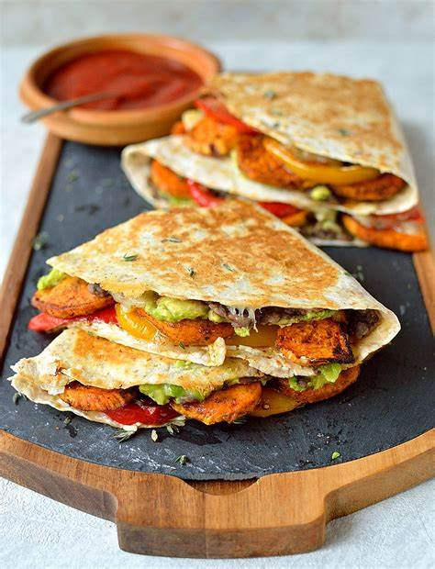  Directions  Step 1  Set the oven at 400 degrees and roast the sweet potato, jalapeno and red pepper on a non-stick sheet pan for about 5 minutes then turn and roast for another 5 minutes. Cook until golden and crispy.  Step 2  Assemble the tortillas with sweet potatoes, jalapeno, bell pepper, black beans, scallions and top off with sprinkles of shredded cheese.  Step 3  Fold the tortillas in half and cook in a hot skillet for about 2 minutes per side. Serve with salsa, guacamole, lime wedges and cilantro  Tips  You can substitute or add other veggies you may have on hand like mushrooms, zucchini or left-over kidney bean potato hash. The quesadilla will cook faster if you pre roast the potato and peppers. Add a Mexican blend spice to season or salt and pepper to taste if you do not like as much spice. Top off with a variety of great toppings like guacamole, salsa or cilantro.

NOTES

