Veggie Scramble
YIELD 2 SERVINGS  Ingredients  2 cup extra firm tofu crumbled into small pieces  1/2 small, diced onion  6 small cremini mushrooms sliced  1 tsp garlic salt  1 tbsp turmeric powder  2 tbsp vegetable stock  1 large kale leaf chopped  1 small carrot shredded  1 garlic clove minced  Salt to taste  Pepper to taste  Nutritionals Per Serving  □ Calories 188 Cal  □ Protein 10 grams  □ Fiber 1 grams  □ Sugar .5 grams  □ Carbs 2 grams  □ Fat 5 grams | PREP 10 MIN | COOK 5 MIN | TOTAL 15 MIN  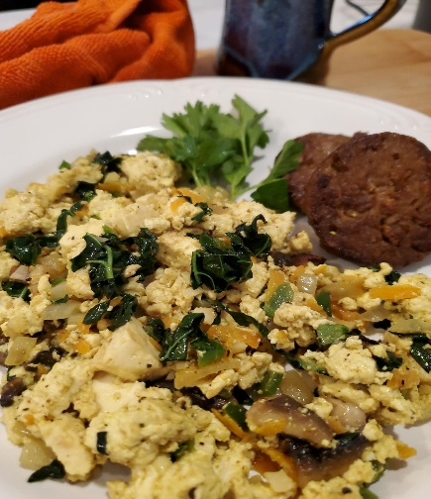  Directions  Step 1  Pat dry the tofu with paper towels. Break up the tofu into bite size crumbled pieces and set aside in a small bowl. Add the vegetable broth to the tofu, garlic salt, turmeric and mix well.  Step 2  Dice the onion, garlic, mushroom and kale. Peel and shred the carrot. Warm a medium size sauté pan. Use a little oil to sauté or you can use a little vegetable broth for reduced fat to sauté the vegetables.  Step 3  Place the onion in a medium sauté pan over medium heat and sauté for 3 minutes until translucent. Add the rest of the veggie and sauté for 3 more minutes. Toss in the tofu, mix well and continue to cook for another 4-5 minutes. Season with salt & pepper to taste and serve hot.  Tips  Once you start heating up the turmeric in food the color deepens and gets more vibrant. You can add any veggies you like, just make sure to sauté the onion first then add the other veggies. I usually cook the root vegetables like carrots a little longer than say kale which cooks fast. Top with guacamole or pickles onions!

NOTES

